Linux, Networking and Cloud Infrastructure: Step-by-Step Practical Report
In this project I learned the basics of the Linux command line, networking, and cloud security settings, and then used them to create, secure, and test a Linux server in the cloud. I did all the work in my own cloud account, with a small free-tier virtual machine, and I used no real or private data.
How to use this document (delete this box before submitting): Follow the steps in order on your own machine and cloud account. Fill the text in [square brackets] with what you really saw, and add your own screenshots. Never put private keys, passwords, or your account ID in a screenshot or in the report. Blur your public IP address if you do not want to show it. I use AWS (Ubuntu on EC2) as the example. Azure, Google Cloud, or DigitalOcean work almost the same way: only the button names change.

1. Objectives and scope
- Learn Linux CLI operations, files and permissions, users and groups, process management, services, and SSH keys.
- Learn IP addressing, DNS, ports, firewalls, and security group settings.
- Deploy a Linux server in this order: Create VM, Configure Linux, Secure Access, Deploy Service, Test Connectivity.
Item | Details
Platform | [AWS / Azure / Google Cloud / DigitalOcean], free tier, account owned by me
Operating system | Ubuntu Server 24.04 LTS (or [your version])
Service deployed | Nginx web server with a simple test page
Scope | Only my own VM. No other system was scanned or tested.
Safety | No real data, billing alert set, and VM deleted at the end

2. Part A: Linux fundamentals
I practiced these commands on my VM (or on a local Linux machine or WSL first).

Step A1: Navigating and working with files
Command | What it does
pwd | Shows the folder I am in
ls -la | Lists files, including hidden ones, with details
cd /var/log | Goes to another folder (cd ~ goes home, cd .. goes up)
mkdir lab | Creates a folder
touch notes.txt | Creates an empty file
echo 'hello' > notes.txt | Writes text into a file
cat notes.txt | Shows the content of a file
cp notes.txt backup.txt | Copies a file
mv backup.txt old.txt | Moves or renames a file
rm old.txt | Deletes a file (careful, there is no recycle bin)
grep 'hello' notes.txt | Searches for text in a file
man ls | Shows the manual of a command

Step A2: Files and permissions
When I run ls -l, I see something like -rw-r--r-- 1 ubuntu ubuntu 6 Oct 25 notes.txt. The first part shows the permissions:
- The first character is the type (- file, d directory).
- Then three groups of three characters: owner, group, and others.
- r = read (4), w = write (2), x = execute (1).
Number | Permission | Example use
7 | rwx | Owner of a script
6 | rw- | Normal private file
5 | r-x | Read and run only
4 | r-- | Read only
0 | --- | No access
Commands I practiced:
chmod 600 notes.txt # only the owner can read and write
chmod 755 script.sh # owner can do everything, others can read and run
chmod u+x script.sh # add execute permission for the owner
chown ubuntu:ubuntu notes.txt # change the owner and group
ls -l notes.txt # check the result
Security lesson: sensitive files like private keys should be 600 or 400, and a file should never be 777 (everyone can do everything).

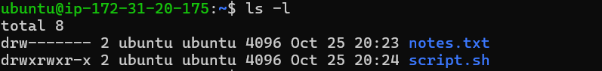Step A3: Users and groups
whoami # my current user
id # my user ID and groups
sudo adduser labuser # create a new user (asks for a password and details)
sudo groupadd labgroup # create a group
sudo usermod -aG labgroup labuser # add the user to the group
groups labuser # show the user's groups
cat /etc/passwd | grep labuser # user entry
cat /etc/group | grep labgroup # group entry
sudo passwd -l labuser # lock the account (to test, then undo with -u)
I learned that sudo gives temporary admin rights, so I should use a normal user and use sudo only when needed, instead of working as root all the time.
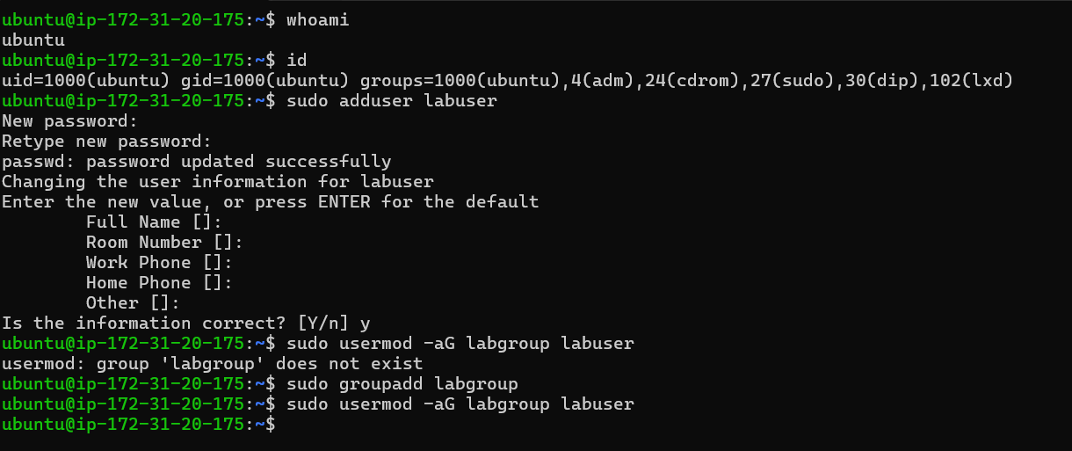

Step A4: Process management
ps aux # list all running processes
ps aux | grep nginx # find a specific process
top # live view of CPU and memory (press q to quit)
pgrep -l sleep # find a process ID by name
sleep 300 & # start a test process in the background
kill <PID> # ask a process to stop nicely
kill -9 <PID> # force stop (last option)

Step A5: Services with systemd
Services (daemons) are programs that run in the background, like the web server or the SSH server.
systemctl status ssh # check a service
sudo systemctl start nginx # start it now
sudo systemctl stop nginx # stop it
sudo systemctl restart nginx # restart it
sudo systemctl enable nginx # start automatically at boot
sudo systemctl is-enabled nginx
journalctl -u nginx --no-pager | tail # service logs

Step A6: SSH keys
SSH lets me control a remote Linux machine securely. SSH keys are safer than passwords. They come as a pair: a private key (secret, stays only on my computer) and a public key (can be shared and is placed on the server).
ssh-keygen -t ed25519 -C 'lab-key' # create a key pair on my own computer
ls ~/.ssh # id_ed25519 (private) and id_ed25519.pub (public)
chmod 600 ~/.ssh/id_ed25519 # protect the private key
I used a passphrase for the private key. I never share or upload the private key and I never show it in screenshots.

3. Part B: Networking fundamentals

Step B1: IP addressing
- An IP address identifies a device on a network. IPv4 looks like 203.0.113.10.
- Private addresses are used inside a network and are not reachable directly from the internet: 10.0.0.0/8, 172.16.0.0/12, 192.168.0.0/16.
- Public addresses are reachable from the internet. A cloud VM usually has both a private and a public address.
- CIDR notation shows the network size. /24 means 256 addresses, and /32 means exactly one address (for example, only my own IP).
ip addr show # my interfaces and private IP
ip route # routing table and default gateway
hostname -I # quick view of IP addresses
curl -s https://checkip.amazonaws.com # my public IP as the internet sees it

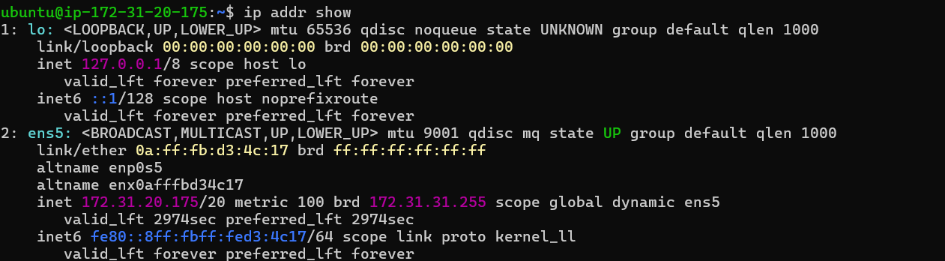 Step B2: DNS
DNS translates names like example.com into IP addresses, like a phone book for the internet.
Record | Meaning
A | Name to IPv4 address
AAAA | Name to IPv6 address
CNAME | Name that points to another name
MX | Mail server for the domain
TXT | Text information (for example, verification)
nslookup example.com
dig example.com A +short
dig example.com MX +short
resolvectl status # which DNS server my Linux machine uses
cat /etc/resolv.conf
DNS setup for my server:
- Option 1 (I own a domain): In my DNS provider (for example, Route 53, Cloudflare, or my domain registrar), I create an A record that points lab.mydomain.com to the server's public IP. I use a fixed IP (for example, an Elastic IP in AWS), because normal public IPs can change after a restart. Then I check it with dig lab.mydomain.com +short.
- Option 2 (no domain): For a local test, I add a line to the hosts file on my own computer, for example <server-public-ip> lab.local, and then open http://lab.local in my browser. I remove this line after the test.
[Screenshot: DNS record or dig result]

Step B3: Ports
A port tells the computer which service should receive the traffic. An address is like a building and a port is like a room number.
Port | Protocol | Service | Should it be open to the internet?
22 | TCP | SSH (remote login) | Only from my own IP
80 | TCP | HTTP (web) | Yes, for a public website
443 | TCP | HTTPS (secure web) | Yes, for a public website
53 | TCP/UDP | DNS | Normally no, unless it is a DNS server
3306 | TCP | MySQL database | No, keep it private
3389 | TCP | Windows Remote Desktop | No, not on a Linux web server
ss -tulpn # services listening on ports on my server

Step B4: Firewalls and security groups
There are two layers of protection:
 | Cloud security group | Linux firewall (UFW)
Where it works | Outside the VM, at the cloud network level | Inside the VM
Controlled from | Cloud console | Terminal
Default for incoming traffic | Everything blocked until I add a rule | Depends on settings
Best practice | Allow only needed ports and sources | Same rules again (defence in depth)
The principle I followed is least privilege: open only the ports that are needed, and only to the people who need them.

4. Part C: Deploy a Linux server
The order is: Create VM, Configure Linux, Secure Access, Deploy Service, Test Connectivity.

Step 1: Create the VM
- Sign in to my own cloud console (I used MFA) and select one region: [region].
- Set a billing alert if I have not done it yet.
- Open the compute service (AWS EC2) and click Launch instance.
- Name: lab-server.
- Image (OS): Ubuntu Server 24.04 LTS.
- Instance type: the smallest free-tier type (for example, t2.micro or t3.micro).
- Key pair: create or import my SSH key pair. For AWS I download the .pem file once and keep it safe. (Or I upload my own id_ed25519.pub public key.)
- Network and security group: create a new security group named lab-sg with these inbound rules:
  - SSH, TCP 22, source: My IP (/32) only.
  - HTTP, TCP 80, source: 0.0.0.0/0 (so the test website can be opened).
  - No other inbound rules.
- Storage: default (for example, 8 GB).
- Launch the instance and wait for the status to become Running. Note the public IP address [IP, blurred].
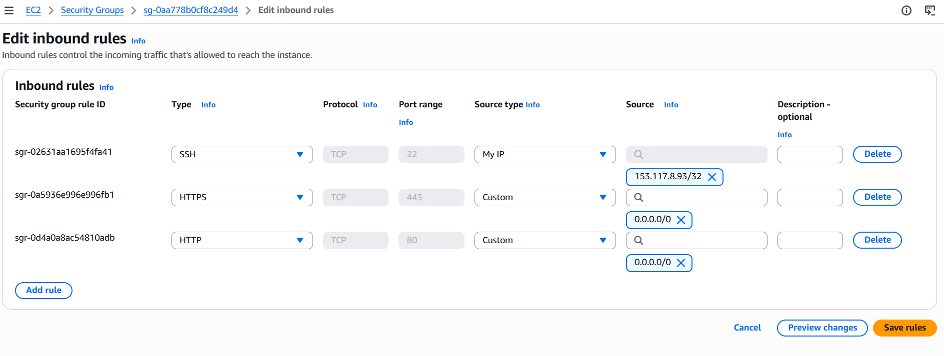
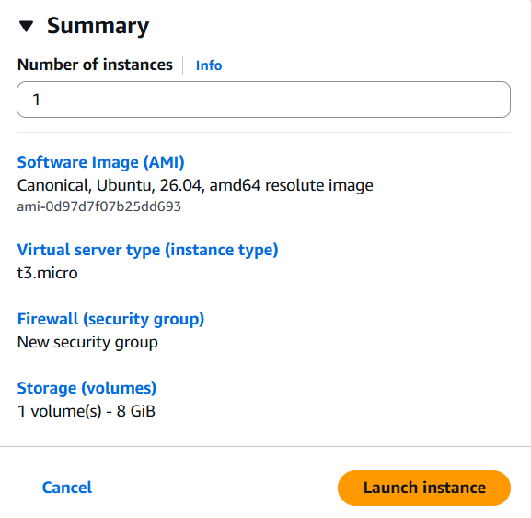

Step 2: Configure Linux
- Protect my key file and connect (replace the key name and IP):
chmod 400 lab-key.pem
ssh -i lab-key.pem ubuntu@<public-ip>
The first time, SSH asks me to trust the server fingerprint. I type yes.
- Update the system:
sudo apt update
sudo apt upgrade -y
- Set the hostname and time zone (optional but neat):
sudo hostnamectl set-hostname lab-server
sudo timedatectl set-timezone Asia/Karachi
- Check basic information:
hostnamectl
uname -a
df -h
free -h

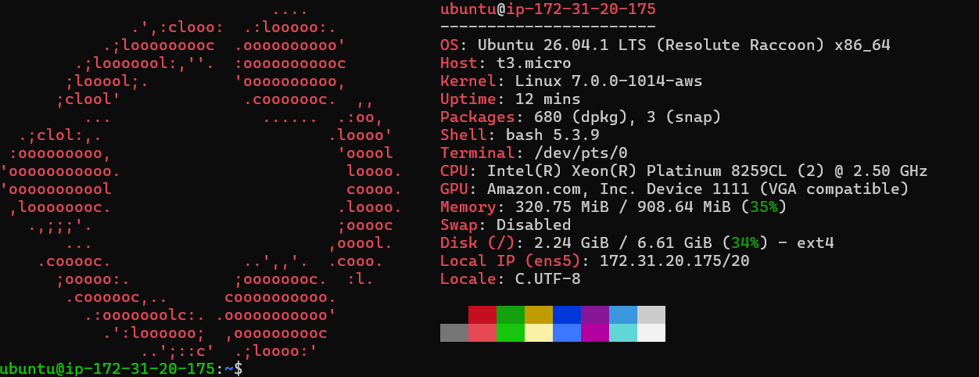

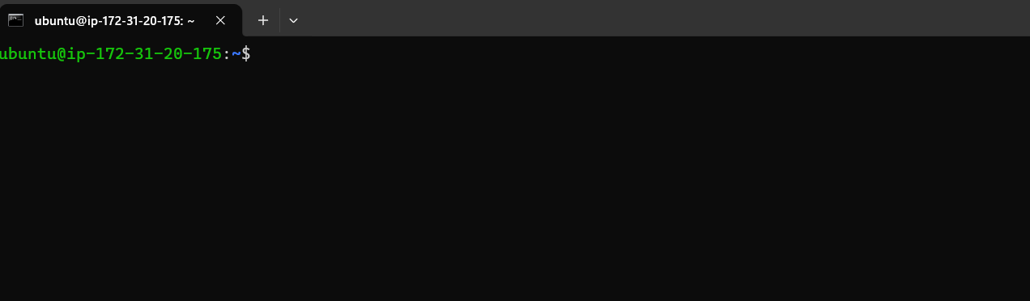

Step 3: Secure access
3.1 Create a normal admin user (instead of using the default user for everything)
sudo adduser labadmin
sudo usermod -aG sudo labadmin
3.2 Give this user my public SSH key
sudo mkdir -p /home/labadmin/.ssh
sudo cp ~/.ssh/authorized_keys /home/labadmin/.ssh/authorized_keys
sudo chown -R labadmin:labadmin /home/labadmin/.ssh
sudo chmod 700 /home/labadmin/.ssh
sudo chmod 600 /home/labadmin/.ssh/authorized_keys
3.3 Open a second terminal and test the new login before changing anything else
ssh -i lab-key.pem labadmin@<public-ip>
sudo whoami # should answer: root
I keep the first session open until this works, so I do not lock myself out.

3.4 Harden the SSH server
sudo nano /etc/ssh/sshd_config
I set (or checked) these lines:
PermitRootLogin no
PasswordAuthentication no
PubkeyAuthentication yes
Some Ubuntu images also have extra settings in /etc/ssh/sshd_config.d/. I checked that they do not turn password login back on. Then I tested the configuration and restarted:
sudo sshd -t
sudo systemctl restart ssh
To prove it works, I tried to log in without the key and it was refused (Permission denied (publickey)).
3.5 Turn on the Linux firewall (UFW)
I allow SSH first, so I do not block myself:
sudo ufw default deny incoming
sudo ufw default allow outgoing
sudo ufw allow 22/tcp
sudo ufw allow 80/tcp
sudo ufw enable
sudo ufw status verbose
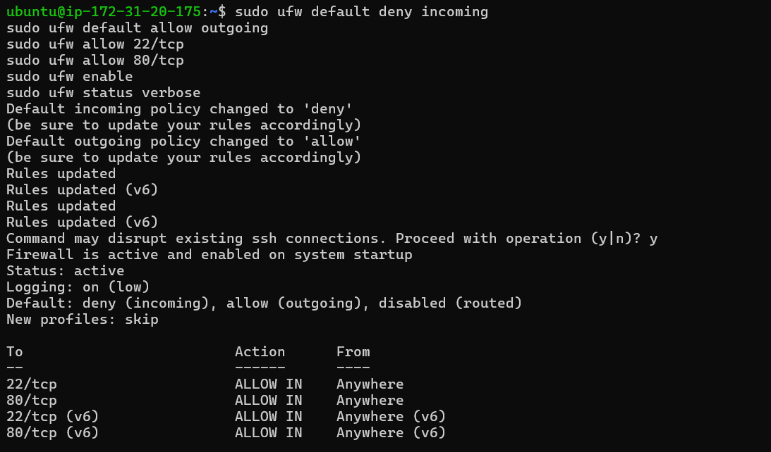
3.6 Optional extra protection
sudo apt install fail2ban -y # blocks IPs that fail to log in many times
sudo systemctl enable --now fail2ban
sudo apt install unattended-upgrades -y # automatic security updates

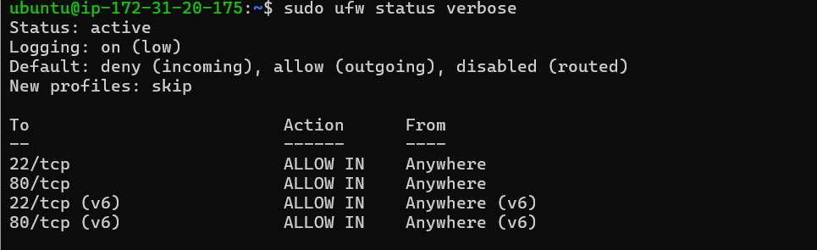
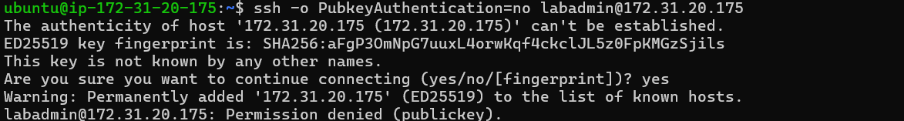

Step 4: Deploy the service (Nginx web server)
sudo apt install nginx -y
sudo systemctl enable --now nginx
systemctl status nginx --no-pager
ss -tulpn | grep :80
Create a simple test page (no private information):
echo '<h1>Lab server is running</h1><p>Linux, networking and cloud practical task</p>' | sudo tee /var/www/html/index.html
curl http://localhost
If I have a domain, I can open http://lab.mydomain.com. If I own a domain and want HTTPS, I can add a free certificate with Certbot (sudo apt install certbot python3-certbot-nginx then sudo certbot --nginx -d lab.mydomain.com). This is optional.
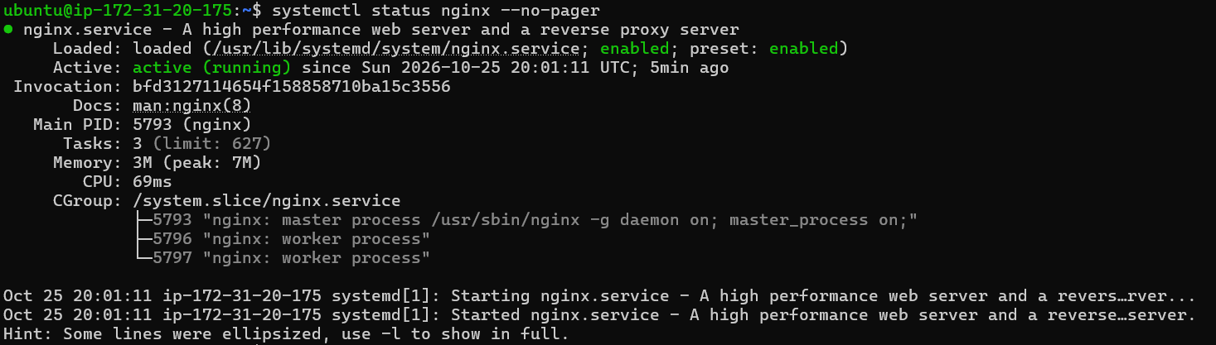

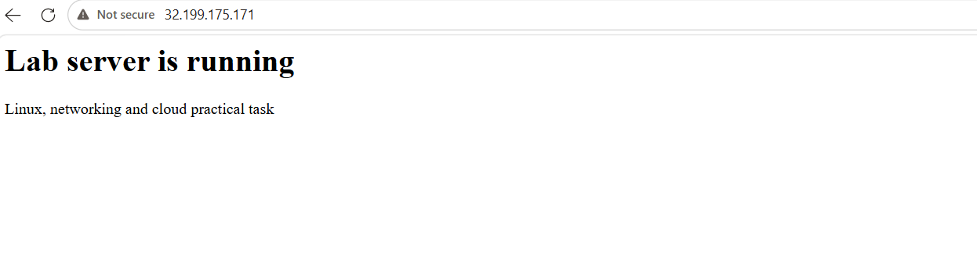

Step 5: Test connectivity
I ran these tests from my own computer (not from the server) against my own server only.
Test | Command or action | Expected result | My result
Web page works | Open http://<public-ip> in a browser | Test page appears | [result]
HTTP headers | curl -I http://<public-ip> | HTTP/1.1 200 OK | [result]
Port 80 reachable | nc -vz <public-ip> 80 | Succeeded | [result]
SSH with key works | ssh -i lab-key.pem labadmin@<public-ip> | Login succeeds | [result]
SSH without key fails | ssh -o PubkeyAuthentication=no labadmin@<public-ip> | Permission denied | [result]
Closed port is blocked | nc -vz -w 3 <public-ip> 8080 | Timed out or refused | [result]
DNS (if used) | dig lab.mydomain.com +short | Shows the server IP | [result]
Firewall test | Temporarily remove the HTTP rule from the security group, reload the page, then add the rule back | Page stops loading, then works again | [result]
On the server I also checked the logs:
sudo tail -n 20 /var/log/nginx/access.log # my web requests
sudo tail -n 20 /var/log/auth.log # SSH logins and failures
sudo ufw status numbered
[Screenshot: browser showing the page] [Screenshot: curl and nc results] [Screenshot: access log entries (hide other people's IPs if any)]

Troubleshooting guide
Problem | Likely cause | What I do
SSH: Connection timed out | Security group does not allow my current IP, or wrong IP address | Update the SSH rule to my current IP and check the public IP
SSH: Permission denied (publickey) | Wrong key, wrong user name, or wrong key permissions | Use the correct key and user, and run chmod 400 on the key
SSH: Unprotected private key file | Key file is too open | chmod 400 lab-key.pem
Web page does not open | Port 80 is not open in the security group or UFW, or nginx is stopped | Check security group, sudo ufw status, and systemctl status nginx
Locked out after UFW | SSH was not allowed before enabling | Use the cloud console's serial or session access, or recreate the lab VM
Domain does not load | DNS record is wrong or not updated yet | Check with dig, and wait for DNS to update
[Write here the real problems I faced and how I solved them.]

5. Cleanup
To avoid cost and leftover risk, at the end I:
- Terminated the VM and deleted any extra disks, fixed IPs, and test DNS records.
- Deleted the security group and the key pair I created for the lab.
- Removed the hosts file line and the lab key from my computer if I do not need it.
- Checked the billing page to make sure no resource was still running.
[Screenshot: instance in terminated state]

6. Results and conclusion
I created a Linux VM in the cloud, connected with an SSH key, created a separate admin user, disabled password and root login, turned on a firewall at two levels (cloud security group and UFW), deployed an Nginx web server, and tested that the allowed services work and unneeded ports are blocked. The result was [for example, the page opened on port 80, SSH worked only with my key, and port 8080 was blocked].

7. What I learned
- Linux basics: files, permissions, users, groups, processes, and services.
- Networking: IP addresses, DNS, ports, and how firewalls decide what traffic can pass.
- Secure server setup: key-only SSH, no root login, least-privilege firewall rules, and updates.
- Testing is part of security: I confirmed both that the allowed things work and that the blocked things really fail.
- Cloud and Linux each have their own firewall, and using both gives stronger protection.

8. Final checklist
- ☐ Work done only in my own account and my own VM
- ☐ Billing alert set and MFA enabled on the cloud account
- ☐ SSH uses keys only, root login and password login are disabled
- ☐ Security group allows SSH only from my IP and only needed ports
- ☐ UFW is enabled with the same rules
- ☐ Nginx is running and the test page opens
- ☐ Tests for allowed and blocked traffic are done and documented
- ☐ No private keys, passwords, account IDs, or tokens in screenshots or text
- ☐ Lab resources deleted after finishing

